**ENG101 Final Examination**

**Fall 2021**

**Duration: 2:30 Hours**

| Name of the Student: | G Suite Email ID: |
| --- | --- |
| Student ID: | Section Number: |
| Total Marks: 20 | Marks Obtained: |

| **Task Instructions:**  **Do the following tasks:**  **Task 1:** Create a **five-paragraph outline** for a Persuasive Essay on ONE topic from the options below. **(5 marks)**  **Task 2:** Write **only three paragraphs [introduction, one body paragraph, conclusion]** of the essay based on the outline. **(15 marks)**  **Task 3:** After completing your writing, download this document as an **MS Word file** and **submit it in Turnitin. Please follow the timer on buX [2 hours 30 minutes].** You have to submit your response on Turnitin within the time limit. |
| --- |
| **Persuasive Essay Topics:**  **[Please highlight your choice]**  **Topic 1: Parents are the best role models in a child's life**  **Or,**  **Topic 2: University students should be engaged in part-time jobs** |

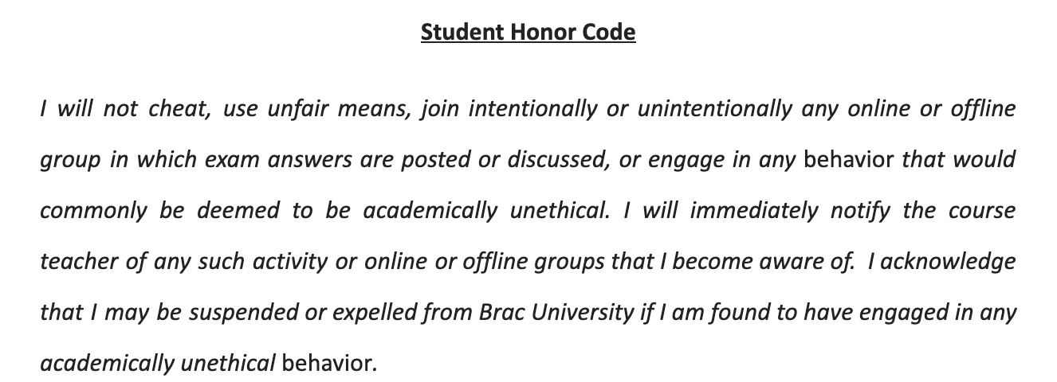

***I agree.***

| ***My Full Name*** |  |
| --- | --- |

**Start writing from here.**

**Task 1 (05 Marks)**

**Create a complete outline for a Persuasive Essay on your chosen topic**

| **Introduction**  Grabber: Can you imagine what it takes for a student to succeed in life? Surely you would think of his academic results and his merits, but what if all these qualities come from before by doing part-time jobs?  Connecting sentences (background information): As the new generation moves forward today, so does our competition, so we need to be prepared in advance so that we can face the competition ahead of time. We need to have the experience of working in advance, the experience of using time well, the experience of being self-reliant which we can do if we can contribute to the development of the country in advance.  Thesis Statement: Therefore, university students should be engaged in part-time jobs as it can improve academic results, boost interpersonal skills and enhance management skills. |
| --- |
| **Reason 1 (Body Paragraph 1)**  Topic sentence 1: To begin with, university students should be engaged in part-time jobs since it can improve students academic results by building their knowledge and boosting their confidence.  Supporting idea 1: Build students' knowledge.  Evidence: According to the Research Gate report, working students have more knowledge and experience as they spend on average 6,5 hours per week at work.  Supporting idea 2: boost students' confidence.  Evidence: According to the Harvard University press report, students doing part time jobs face more challenging experiences and it helps to boost their confidence.  Concluding sentence: Thus, because students should be engaged in part time jobs, improve students academic results by building their knowledge and boosting their confidence. |
| **Reason 2 (Body Paragraph 2)**  Topic sentence 2: Secondly, students should be engaged with part time jobs as it can boost interpersonal skills by developing the unemployment rate and building a professional network.  Supporting idea 1: develop the employment rate.  Evidence: According to the Walden University study report, nearly 30% of the students are employed which is increasing our employment rate.  Supporting idea 2: build a professional network.  Evidence: According to the careeraddict report, students doing part time jobs gain more experience by meeting new people and it gives them a wider connection of having more opportunities.  Concluding sentence: This is how students engaged in part time jobs can develop the employment rate and build a professional network which can boost their interpersonal skills. |
| **Reason 3 (Body Paragraph 3)**  Topic sentence 3: Thirdly, students should be engaged in part time jobs as it enhances their management skills by improving their time management and having work experience.  Supporting idea 1: enhance their time management.  Evidence: According to the Walden University study report, students working in part time jobs can make a balanced schedule than the normal students as they have knowledge about balancing study and job times.  Supporting idea 2: have work experience.  Evidence: According to the careeraddict report, students doing part time jobs get work experience before other students and it opens more opportunities for them.  Concluding sentence: Therefore, students should be engaged in part time jobs as it enhances their management skills by improving their time management and having work experience. |
| **Conclusion**  Restatement of the Thesis: To conclude, varsity students should be involved in part-time occupation since it can uplift education results, improve interpersonal expertise and boost management capability.  Suggestions,recommendations: Further, university students should do part time jobs as it can build their experience and it will help them to create a better career from the beginning.  Clincher: In conclusion, University students should be engaged in part-time jobs as it can improve academic results, boost interpersonal skills and enhance management skills. |

**Task 2 (15 marks)**

Write ONLY the **Introduction**, **one Body Paragraph**, and the **Conclusion** below.

Introduction

| Can you imagine what it takes for a student to succeed in life? Surely you would think of his academic results and his merits, but what if all these qualities come from before by doing part-time jobs? As the new generation moves forward today, so does our competition, so we need to be prepared in advance so that we can face the competition ahead of time. We need to have the experience of working in advance, the experience of using time well, the experience of being self-reliant which we can do if we can contribute to the development of the country in advance. If every student thinks about their future in advance, it will help them to dig into the future and build a little better career. Therefore, university students should be engaged in part-time jobs as it can improve academic results, boost interpersonal skills and enhance management skills. |
| --- |

One Body Paragraph

| To begin with, university students should be engaged in part-time jobs since it can improve students academic results by building their knowledge and boosting their confidence. Further, from his work he can gain knowledge in various subjects which enhances his experience and intelligence. Their general knowledge will also increase through working. According to the Research Gate report, working students have more knowledge and experience as they spend on average 6,5 hours per week at work. Furthermore, while working, he can gain experience in talking to different types of people and even in gatherings and crowded places, which can give him more confidence. They can talk to different types of people through their work which also increases their confidence. According to the Harvard University press report, students doing part time jobs face more challenging experiences and it helps to boost their confidence. Thus, because students should be engaged in part time jobs, improve students academic results by building their knowledge and boosting their confidence. |
| --- |

Conclusion

| To conclude, varsity students should be involved in part-time occupation since it can uplift education results, improve interpersonal expertise and boost management capability. Further, university students should do part time jobs as it can build their experience and it will help them to create a better career from the beginning. If we give every student the opportunity to work in advance, then in every field of his life his work experience and achievement will be useful and by doing so the student can benefit in different ways. In addition to their work experience, they will learn many more things that will be useful in many areas of their lives. In conclusion, university students should be engaged in part-time jobs as it can improve academic results, boost interpersonal skills and enhance management skills. |
| --- |

**Task 3**

**After completing your writing, download this document as an MS Word file and submit it in Turnitin.**